Gibbs Farm Youth Intern Application
Summer 2023
Please fill out form and return to Gibbs Farm or email scanned copy to janie@rchs.com

____________________________ ____ _____________________________
First Name of Participant Middle I. Last Name
____________________________ _________
Preferred Name (if different from first name) Date of Birth

_________________________________ ________________ ____
Street Address City State

__________________________________________ _______________________________
Parent/Guardian First Name Parent/Guardian Last Name

__________________________________________ __________________________________
Participant Cell Phone Number (if applicable) Parent/Guardian Cell Phone Number

________________________________ ______________________________
Participant Email Parent/Guardian Email

Have you interned at Gibbs Farm before? Yes No
How did you hear about the Gibbs Farm Youth Intern Program? ___________________
_____________________________________________________________________________________

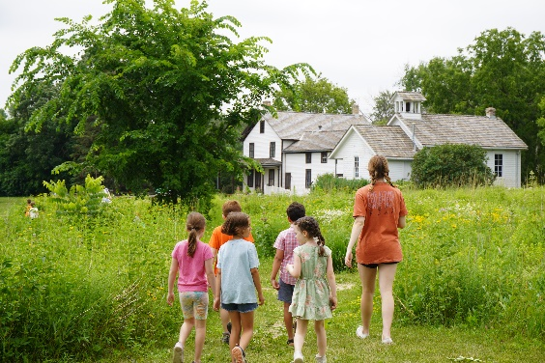

Name of Participant (Please Print)
Date:
Signature of Participant

Name of Parent/Guardian (Please Print)
Date:
Signature of Parent/Guardian

Why are you interested in volunteering at Gibbs Farm?
Please write 5-8 sentences.
____________________________________________________________________________________________________________________________________________________________________________________________________________________________________________________________________________________________________________________________________________________________________________________________________________________________________________________________________________________________________________________________________________________________________________________________________

Do you have any applicable historic skills you would be able to share?
(i.e. sewing, playing the fiddle, whittling, drawing, gardening, etc)
If so, please describe: _____________________________________________________________

Summer Youth Intern Availability 2023

Please fill out the preliminary availability sheet below by checking or highlighting the dates that you will likely be able to work. This gives us an idea of your schedule for the summer—it is most helpful if interns are available for entire “camp weeks” (Tues.-Thurs.)
This summer, interns must be available for four weeks of camp (12 days) at a minimum.
You will not necessarily be scheduled for the dates you are available.

June
2023
Tuesday | Wednesday | Thursday | Friday
20 | 21 | 22 | 23
Kids on the Farm 8:30-1:30 | Kids on the Farm 8:30-1:30  PeeWees 9:00-12:00 | Kids on the Farm 8:30-1:30 | PeeWees 9:00-12:00
27 | 28 | 29 | 30
Dakota Camp 8:30-1:30 | Dakota Camp 8:30-1:30  PeeWees 9:00-12:00 | Dakota Camp 8:30-1:30 | PeeWees 9:00-12:00

July
2023
Tuesday | Wednesday | Thursday | Friday
4th of July – No Programs | 5th of July – No Programs | 6 | 7
 |  | One Day Victorian Ladies  8:30-3:00 | PeeWees 9:00-12:00
11 | 12 | 13 | 14
Nature Detectives 8:30-1:30 | Nature Detectives 8:30-1:30  PeeWees 9:00-12:00 | Nature Detectives 8:30-1:30 | PeeWees 9:00-12:00
18 | 19 | 20 | 21
Minnesota Time Travel 8:30-3:00  Gibbs Girl 8:30-1:30 | Minnesota Time Travel 8:30-3:00  Gibbs Girl 8:30-1:30  PeeWees 9:00-12:00 | Minnesota Time Travel 8:30-3:00  Gibbs Girl 8:30-1:30 | PeeWees 9:00-12:00
25 | 26 | 27 | 28
Kids on the Farm 8:30-1:30 | Kids on the Farm 8:30-1:30  PeeWees 9:00-12:00 | Kids on the Farm 8:30-1:30 | PeeWees 9:00-12:00

August
2023
Tuesday | Wednesday | Thursday | Friday
1 | 2 | 3 | 4
Dakota Camp 8:30-1:30 | Dakota Camp 8:30-1:30  PeeWees 9:00-12:00 | Dakota Camp 8:30-1:30 | PeeWees 9:00-12:00
8 | 9 | 10 | 11
Nature Detectives 8:30-1:30 | Nature Detectives 8:30-1:30  PeeWees 9:00-12:00 | Nature Detectives 8:30-1:30 | PeeWees 9:00-12:00
15 | 16 | 17 | 18
Farm Survivor 8:30-3:00  Gibbs Girl 8:30-1:30 | Farm Survivor 8:30-3:00  Gibbs Girl 8:30-1:30  PeeWees 9:00-12:00 | Farm Survivor 8:30-3:00  Gibbs Girl 8:30-1:30 | PeeWees 9:00-12:00
22 | 23 | 24 | 25
Kids on the Farm 8:30-1:30 | Kids on the Farm 8:30-1:30  PeeWees 9:00-12:00 | Kids on the Farm 8:30-1:30 | PeeWees 9:00-12:00
29 | 30 | 31 | September 1
Dakota Camp 8:30-1:30 | Dakota Camp 8:30-1:30  PeeWees 9:00-12:00 | Dakota Camp 8:30-1:30 | PeeWees 9:00-12:00

